# Project 1 Report

## Intro

In order to facilitate the administration of network, many automation tools have been developed such as SolarWinds Network Configuration Manager, ManageEngine Network Configuration Manager, Lan-Secure Configuration Center, Ansible, BMC TrueSight Automation for Networks. A small lab was set up to demonstrate the use of ansible (network automation tool) to connect to the routers and configure them and to install program on Linux machine remotely. This will mainly demonstrate the benefits that ansible brings to the table for network engineers.

Why to automate the network?

* Reduce errors
* Less time consuming
* Only one pc can deploy every device
* Reduce Risk of human errors and more reliable

Why to automate using ansible?

* 1 script works faster than 1 person
* Automate manual work
* Automate deployment
* Configuration management
* Modules and inventory

## LAB Schema

1. Configure the following network schema.

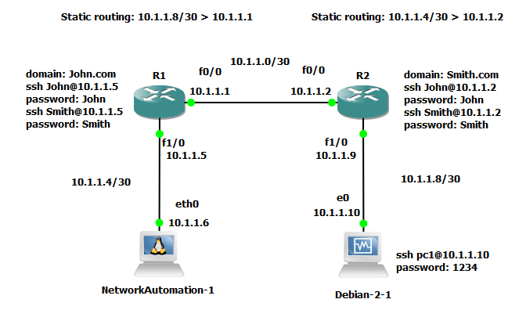

1. Use Ansible to: -
2. configure lo0 on R1 > 1.1.1.1 255.255.255.255 and configure lo0 on R2 > 2.2.2.2 255.255.255.255.
3. configure MOTD on R1 and R2.
4. install apache on pc2.

## Improved LAB Schema

1. Configure the following network schema.
   1. Open Shortest Path First (OSPF) has been configure rather than static routing.
   2. In order not to disturb the 2 initial routers, a 3rd one was added.
   3. Use of the NAT in GNS3 to allow internet in my network.

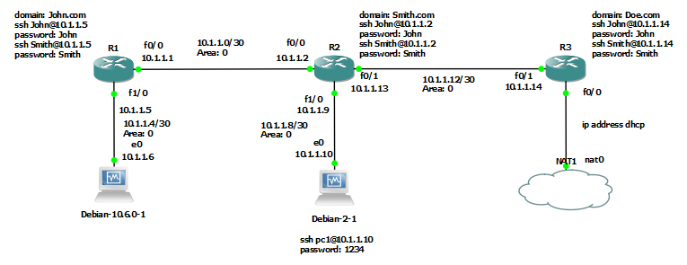

1. Use Ansible to: -
   1. configure lo0 on R1 > 1.1.1.1 255.255.255.255, configure lo0 on R2 > 2.2.2.2 255.255.255.255, and configure lo0 on R3 > 3.3.3.3 255.255.255.255.
   2. configure MOTD on R1, R2 and R3.
   3. install apache on pc2.

## Testing the built network

### Ping test

From pc1 being able to ping pc2:

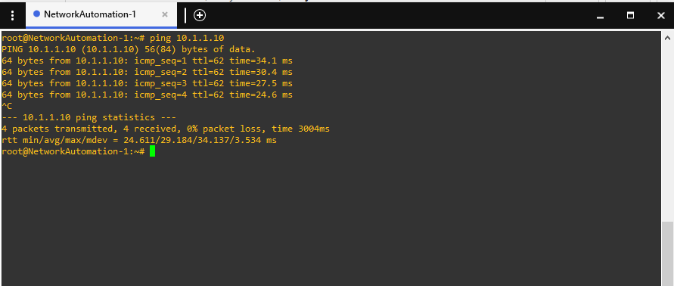

From pc2 being able to ping pc1:

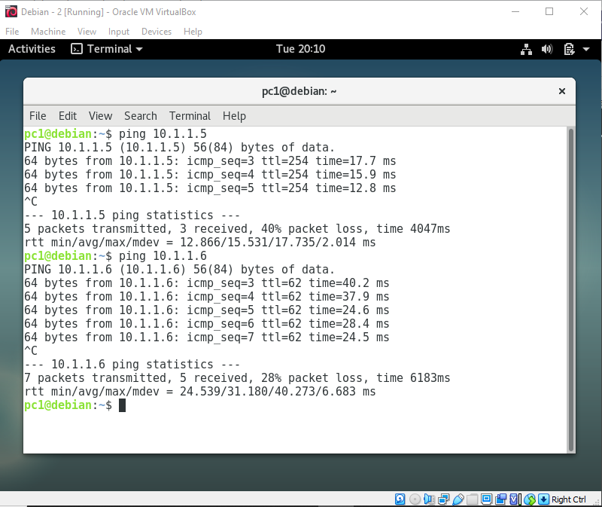

### SSH test

From PC1 both John and Smith can SSH on R1.

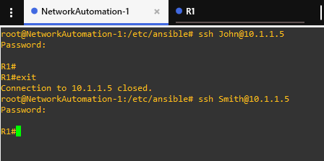

From PC1 both John and Smith can SSH on R2.

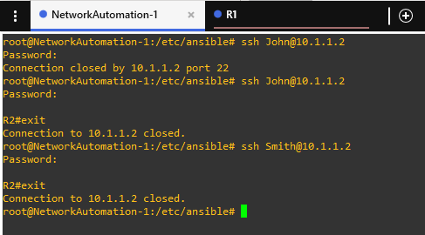

From PC1 SSH on PC2.

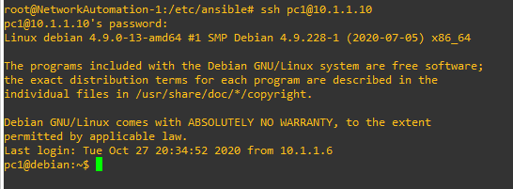

## Testing the playbook.yml

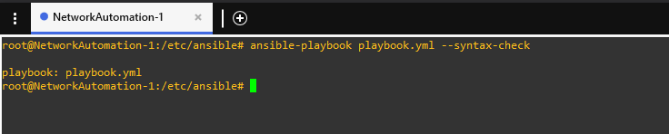

## Running the playbook.yml

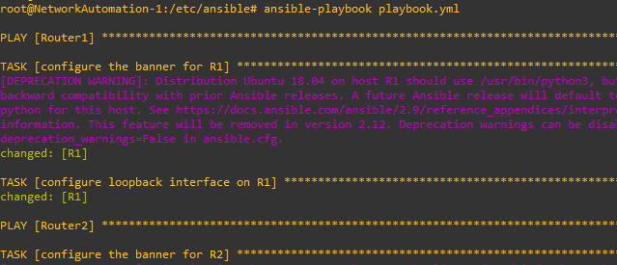

## Speed testing

A small speed test was carried in order to determine how much time it will take for a beginner, intermediate, and pro will be taken to perform the task without ansible.

|  |  |  |  |
| --- | --- | --- | --- |
|  | Routers’ configurations | PC’s Configurations | Total(seconds) |
| Beginner |  |  |  |
| Intermediate |  |  |  |
| Pro |  |  |  |

## Conclusion

The speed testing has concluded that even the pro has not been able to go faster than the ansible script (approximately 40 seconds). As the Intro stipulate this lab has demonstrate how to ease the way of configuring lots of routers and other machines at one go. Ansible has been a powerful configuration management tool for deploying software and administering remote systems in our case installing software.

## Modules used

cisco.ios.ios_config

cisco.ios.ios_banner

apt

## All configs

https://github.com/Arouven/Network/